C O N S U L T A T I O N
Notice Boards
There are currently notice boards at the following location in the Village:-
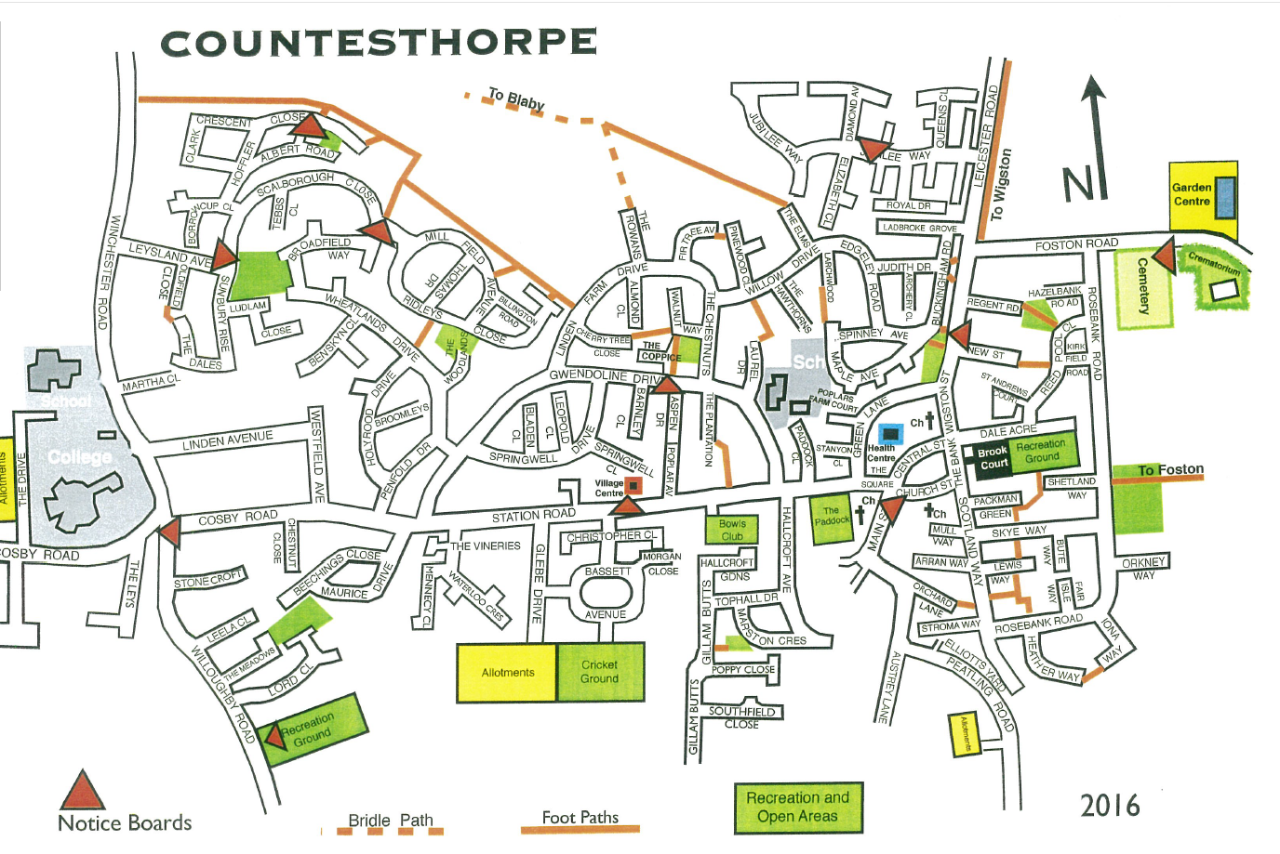
You can send us information, preferably in JPEG Format or PDF and we can upload to our Village Events Notice Board
The Parish Council Notice Boards are located at the following locations:-
- Countesthorpe Village Hall  - Cosby Road crossroads  - Willoughby Road Playing Fields  - Sunbury Rise  - Hoffler Close  - The Square | - Ridleys Close  - Gwendoline Drive (Opposite junction with Aspen Drive)  - Jubilee Way  - Main Street (The Pound)  - The Spinney (Buckingham Road)

QUESTIONNAIRE - YOUR OPINION ON THE NOTICE BOARDS
If you save this document and check the relevant boxes it can be returned to us by email at manager@countesthorpeparishcouncil.co.uk . Alternatively we will be collecting at the Library/Parish Council Office, Countesthorpe Village Hall, Station Road.
Firstly, are you generally interested in what is going on in the Village or news on the issues affecting the Village?
☐Yes, I am generally interested in what’s going on in Countesthorpe
☐I generally source information on what’s going on in Countesthorpe if I have heard about a particular issue or event that is affecting the village.
☐Neither of the above

Please continue overleaf

What is your preferred method of finding out what is going on in the Village? (Please tick all that apply)
☐Word of Mouth
☐Parish Council Facebook Page
☐Parish Council Notice Boards
☐Parish Council Website Page
☐Other Countesthorpe Facebook Pages or social media sites
☐Posters displayed in the local shops
☐The Herald
☐Mailshots
Other …………………………………………………………………………………………………………………

Which of the following would best describe why you would access information from a Parish Council notice board.
☐I am walking to the local shops or going to the local parks and I have a look at the notice board when I am passing by.
☐I do not have access to the internet or social media so I monitor the information on the notice boards.
☐I have heard word of mouth about an event or news in the village so I purposefully go to look at a notice board.

Which of the following do you take notice of on the Notice Boards? (Please select all that apply)
☐To access details about contacting the Parish Council such as my local Councillor
☐Official information regarding the Parish Council such as dates of meetings etc
☐News on issues that are affecting the village
☐Posters of events that are going on in the village
☐Details of regular activities that are going on in the village
Please specify any other information you would like to be published on the noticeboards……………………………………………………………………………………………………………………………………………………..

What is your view of the current locations of the Noticeboards?
☐I think they are currently in good locations as I regular pass one.
☐There is not a notice board that covers the area where I walk or visit
☐Recommended location for a noticeboard to be positioned ………………………………………………..………….
☐Recommended removal of noticeboard …………………………………………………………………………………………

What is your age group?
☐16-20 years old
☐21-25 years old
☐26-45 years old
☐46-65 years old
☐66-75 years old
☐75 years plus

If you have any comments that you would like to talk to the Parish Council about directly, please email the Manager of the Parish Council at manager@countesthorpeparishcouncil.co.uk . Tel: 0116 2779518
Thank you for your time

