Submitting a comment via Blaby District Council’s Planning Portal
Planning application | Planning application number | Date to submit comment by
Land adjacent to Leicester Road and Foston Road | 23/1071/OUT | 13th February 2024
Land East of Willoughby Road | 24/0001/OUT | 14th February 2024
Land off Gillam Butts | 24/0004/FUL | 14th February 2024
Useful Information:

Mon | Tues | Weds | Thurs | Fri | Sat | Sun
9am-5pm | 9am-1pm | CLOSED | 9am-5pm | CLOSED | 9am-1pm | CLOSED
If you wish to submit a comment online but do not have access to a computer or the internet, there are three public computers in Countesthorpe Library which are available for use. Please be aware of the Library opening hours below:
Please note: An email address is required in order to submit a comment successfully online

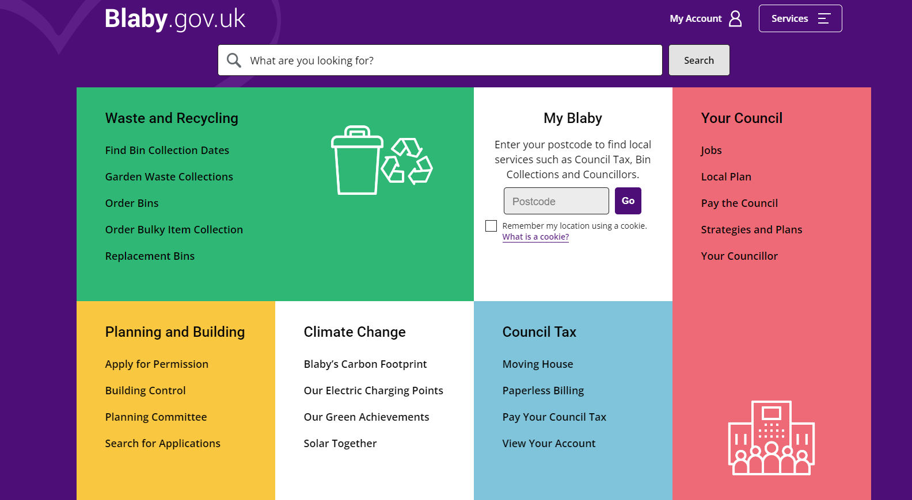
Step 1
Visit www.blaby.gov.uk
Look under the yellow ‘Planning and Building’ section
Select ‘Search for Applications’

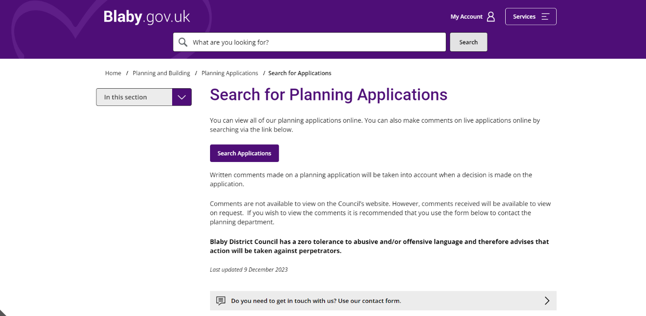
Step 2
Select the purple ‘Search Applications’ button

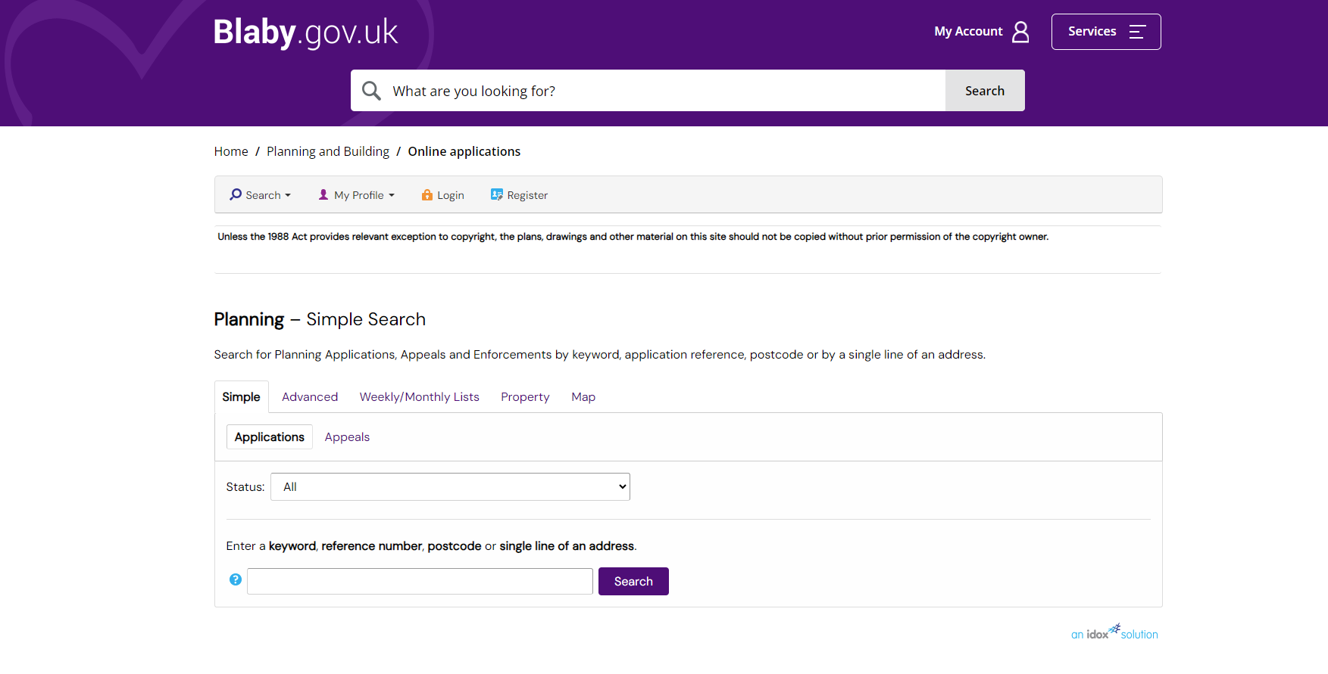
Step 3
Enter the Planning Application Number (found on the first page of this document) in the search box and select the purple ‘Search’ button

You should then be taken to the ‘Application Summary’ page
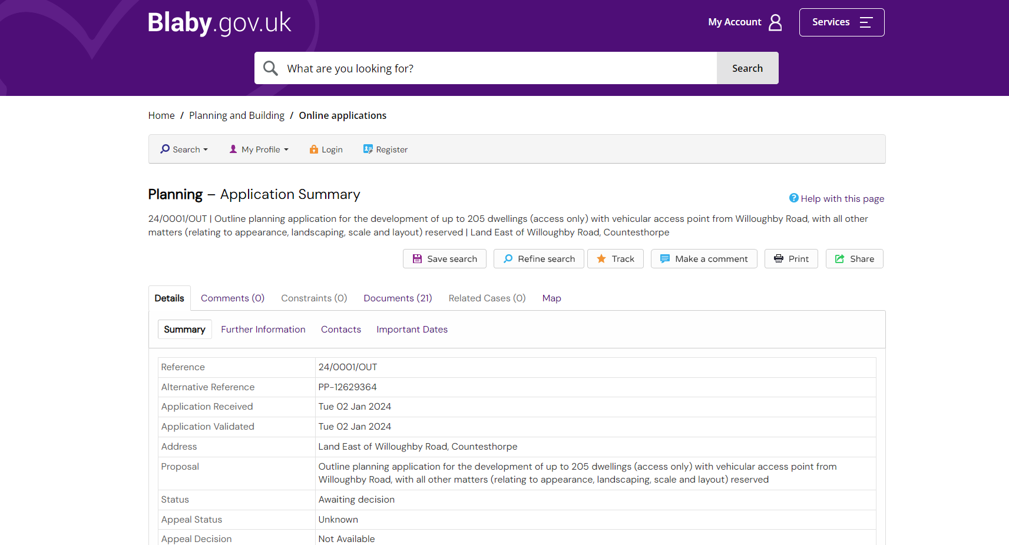

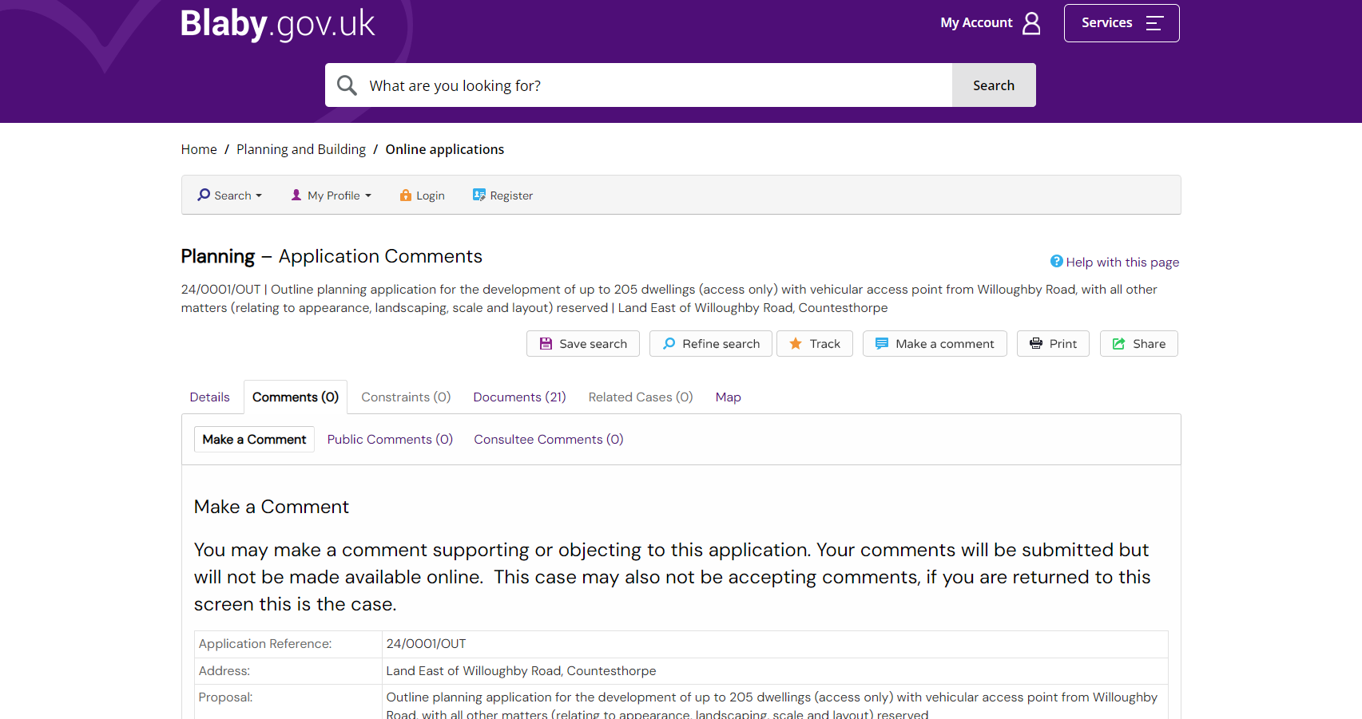
Step 4
Select ‘Comments’ to take you to the ‘Application Comments’ page

‘Make a Comment’ will already be selected for you

Step 5
Enter your information in the text boxes, ensuring that any of the required fields,
indicated by an *, are completed
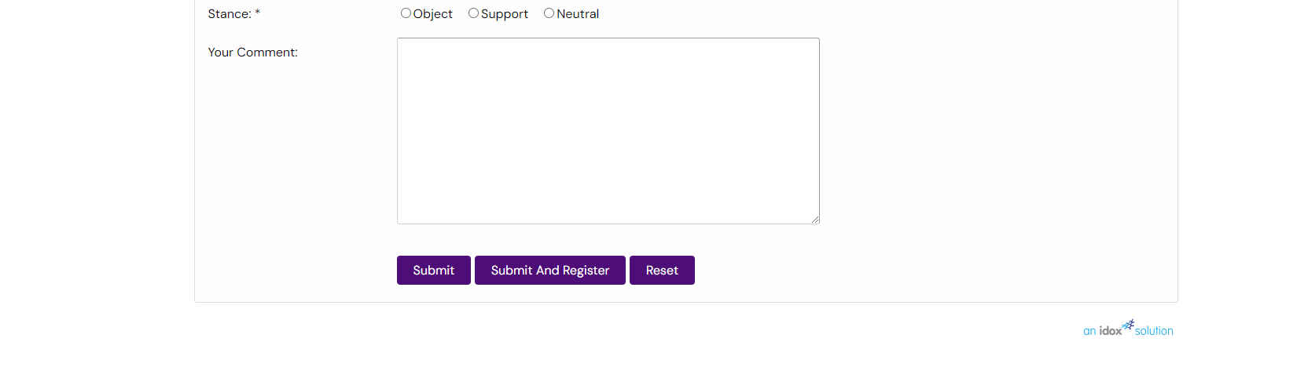
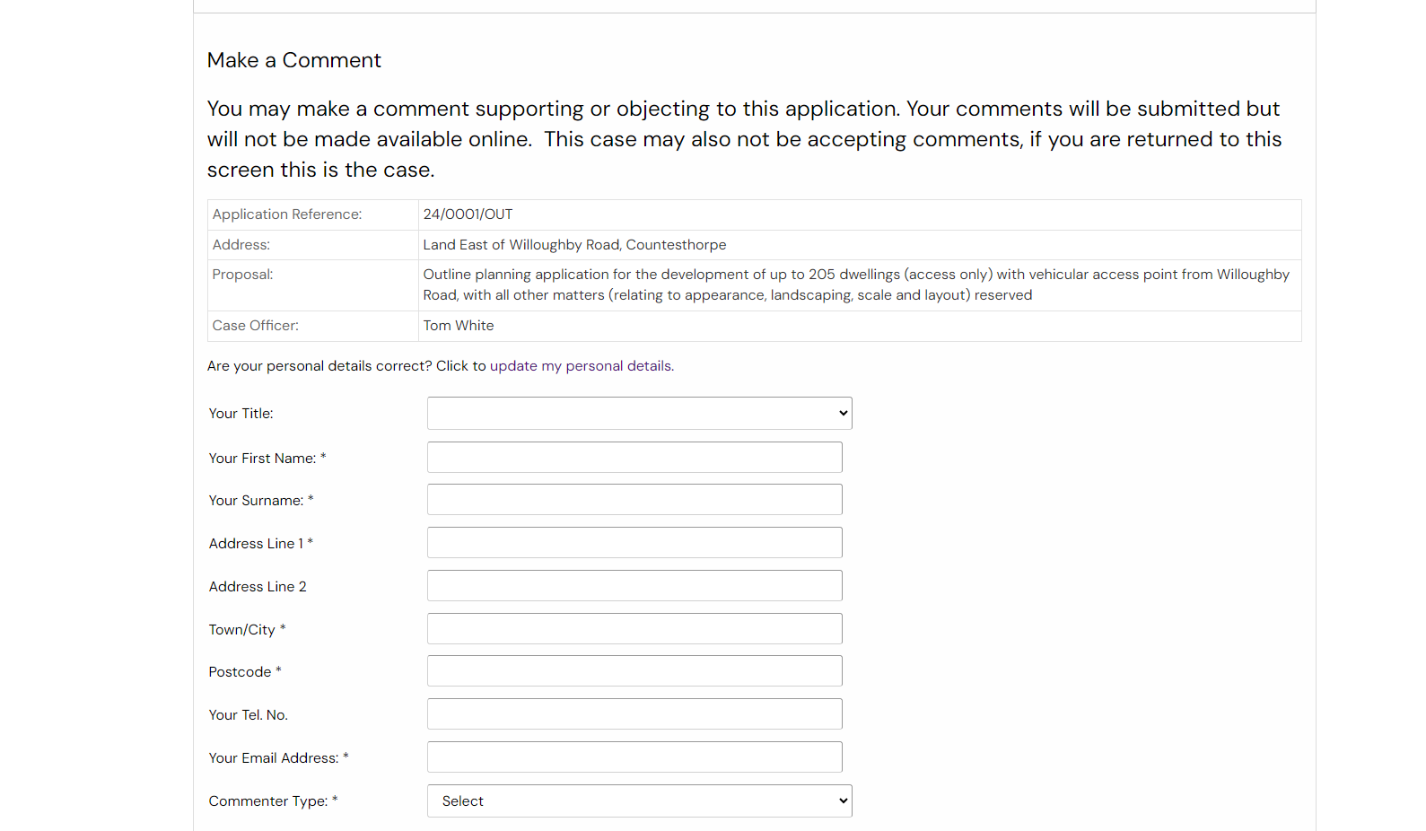

Step 6
Once you are happy with the information entered, select the purple ‘Submit’ button

