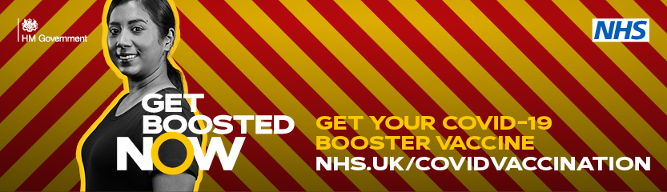

GET BOOSTED NOW
TOOLKIT FOR LLR

Core script – key points

On Sunday 12 December the Government announced a major drive to speed up the covid booster vaccination programme in response to the Omicron variant

Scientists are very worried about the arrival of the Omicron variant because of the speed with which it spreads and there is currently no data on its severity and its impact on the NHS.

Because two vaccine doses do not give us the protection, we all need to get the booster vaccine

As well as the impact of Covid on individual people’s health, the potential for an increase in hospital admissions means it will impact on an already hard-pressed NHS at its most busiest time when it has to deal with winter pressures. The NHS is also trying to recover from the impact of earlier waves of the pandemic and reduce waiting lists for non-covid conditions.

The booster jab can restore protection to around 75%, so the NHS is turbo-charging the booster programme to offer a top up to all eligible adults by the end of the year.

The Omicron variant is causing major concern: it is spreading rapidly we don’t yet know how seriously ill people can become from the variant but we are starting to see more cases of people admitted with the Omicron variant.

The vaccination programme has been a fantastic success: nearly 2 million doses have been given in Leicester, Leicestershire and Rutland

Who is eligible?

Booster vaccinations are now available to all adults over 18 who have had their second dose 3 months ago (91 days). People can book around 61 days after their second dose but won’t be able to have the vaccine until a minimum of 3 months has passed

About the vaccines

Anyone who gets COVID-19 can become seriously ill or have long-term effects (long COVID). The COVID-19 vaccines are the best way to protect yourself, loved ones and others in your community.

Research has shown the vaccines:
- reduce your risk of getting seriously ill or dying from COVID-19
- reduce your risk of catching or spreading COVID-19
- protect against COVID-19 variants
There are currently 3 vaccines being given by the NHS: Astra – Zeneca, Pfizer and Moderna

Safety of vaccines

The COVID-19 vaccines approved for use in the UK have met strict standards of safety, quality and effectiveness. The vaccines have been tested extensively in pilot studies on thousands of people

They can cause some side effects, but not everyone gets them. Any side effects are usually mild and should not last longer than a week, such as:
- a sore arm from the injection
- feeling tired
- a headache
- feeling achy
- feeling or being sick
More serious side effects, such as allergic reactions or blood clotting, are very rare.

Getting your booster vaccines

There are now more options to get your vaccine:
- Booked appointments
- Walk-ins
- Longer opening hours, into the early evening
- Range of different locations across LLR: Community Pharmacists, vaccine sites, pop-up sites in specific locations e.g. King Power Stadium and Highcross shopping centre
To find a site near you to either book an advanced appointment or find a ‘Walk-in’ site, the following link should be given:

https://www.nhs.uk/conditions/coronavirus-covid-19/coronavirus-vaccination/

You can also call the National Booking Service (NBS) on 119

Local information is also available at https://www.leicestercityccg.nhs.uk/my-health/coronavirus-advice/coronavirus-vaccine/

What’s App message

A suggested message to share with your networks/groups is:

All adults 18+ are eligible for a covid booster vaccine if you had a second dose 3 months ago. The booster dose gives you the best protection against becoming seriously ill the new Omicron variant. Please get your booster as soon as you can. Go to www.nhs.uk/conditions/coronavirus-covid-19/coronavirus-vaccination/ for more information. If you want more information about boosters see www.gov.uk/government/publications/covid-19-vaccination-booster-dose-resources

Information on sites providing booster vaccinations is available at: https://www.leicestercityccg.nhs.uk/my-health/coronavirus-advice/coronavirus-vaccine/

Copy for general use on websites, emails and bulletins

Get Boosted Now

The whole NHS is on a mission to turbo-charge the COVID-19 booster programme and protect communities against the new Omicron variant, as well as being there for those who need care urgently.

In Leicester, Leicestershire and Rutland the public response has already been incredible, with nearly 2 million vaccinations taking place so far.

The Omicron variant is a new threat. It is spreading rapidly and has the potential to significantly increase pressures on the local NHS. By 31 December the NHS wants to massively increase the number of people having their booster vaccine to protect people from serious illness from Covid.

Everyone 18 years and over is eligible for a booster jab three months after their second and is urged to get one.

UK Health Security Agency data shows that two doses of a Covid-19 vaccine are not enough to stop people becoming unwell from Omicron, but a booster jab will increase protection to 75%.

Getting your booster vaccine is easy, there are accessible and convenient locations across Leicester, Leicestershire and Rutland and vaccinations can be booked or you can walk-in to some locations. Over the next two weeks there are extended opening times at some sites. Locations include larger vaccination sites, community pharmacists and in some areas, there will be ‘pop-up’ sites.

Information on the availability of sites can be found through the NHS Booking Service (NBS) https://www.nhs.uk/conditions/coronavirus-covid-19/coronavirus-vaccination/book-coronavirus-vaccination/ or call 119 to guarantee your jab.

Additional local information is also available at https://www.leicestercityccg.nhs.uk/my-health/coronavirus-advice/coronavirus-vaccine/

Information about the booster vaccine is available in this patient leaflet https://www.gov.uk/government/publications/covid-19-vaccination-booster-dose-resources

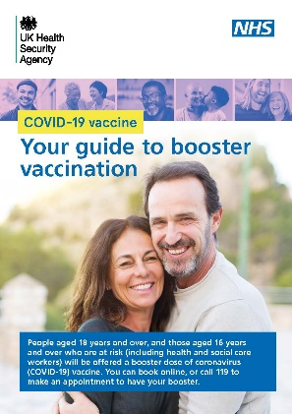
And online here: https://www.nhs.uk/conditions/coronavirus-covid-19/coronavirus-vaccination/coronavirus-booster-vaccine/

Suggested social media assets and posts

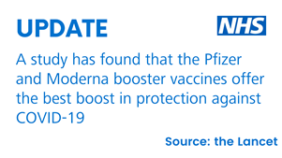 | All adults 18+ are now eligible for boosters. # Get Boosted Now visit www.nhs.uk/conditions/coronavirus-covid-19/coronavirus-vaccination/
Get the best possible protection from the Omicron variant by getting your Covid booster.  Get yours at one of our walk-in clinics or book an appointment.  For the full list of walk-in clinics and to see if you’re eligible: https://bit.ly/LLRVacBook  #GetVaxxedStayOnTrack | 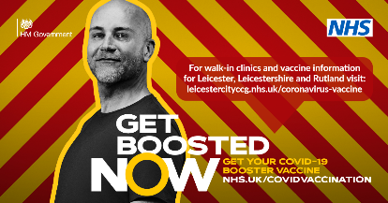
All adults in England are now eligible for a Covid19 booster, if you had your second dose at least three months ago.  Book yours now by visiting https://www.nhs.uk/conditions/coronavirus-covid-19/coronavirus-vaccination/book-coronavirus-vaccination/  For local walk-in clinics visit https://bit.ly/LLRVacBook | 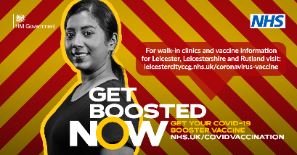
If you’re 18+ you can get the #CovidBoosterVaccine 3 months after your 2nd jab. Get yours at one of our walk-in clinics or book an appointment.  For the full list of walk-in clinics and to see if you’re eligible: https://bit.ly/LLRVacBook  #GetVaxxedStayOnTrack | 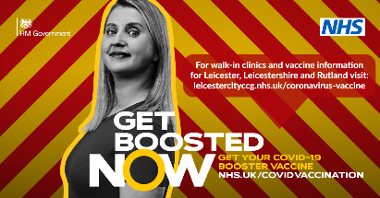
Book your COVID booster if you’re:  - aged 18+  - aged 16+ with a health condition that puts you at high risk from COVID-19  - a frontline health and social care workers  Protect yourself, your friends and your family. Get Boosted Now.  https://bit.ly/LLRVacBook | 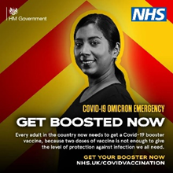
Find out where your nearest walk-in vaccine clinic is taking place this week/ weekend.  Protect yourself, your friends and your family. Get Boosted Now.  Visit https://bit.ly/LLRVacBook | 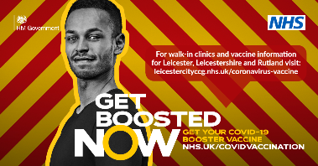
Walk-in vaccine clinics are taking place during the festive period.  To find your nearest clinic visit https://bit.ly/LLRVacBook  Protect yourself, your friends and your family. Get Boosted Now. | 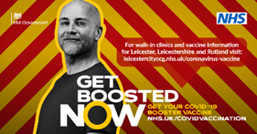
Watch the below video to hear from Professor Chris Whitty as he explains the importance of getting your Covid-19 Booster.  For more info and details of local walk-in clinics visit https://bit.ly/LLRVacBook | Professor Chris Whitty video or  https://www.youtube.com/watch?v=VqhMMKHqEdk

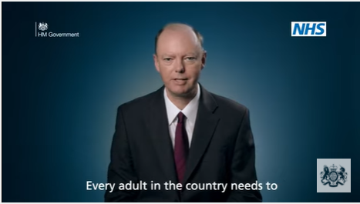
https://www.youtube.com/channel/UCXmtnbNO7_no7RekfUIqVcw

Video from Chris Whitty

30 second radio ad

