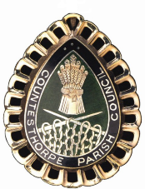
COUNTESTHORPE PARISH COUNCIL
PERSON SPECIFICATION

Job Title Assistant Parish Council Manager to the Council

Criteria | Essential (E)/  Desirable (D)
Knowledge  Understanding of Microsoft office applications  Previous experience of accounting software  Previous experience in Local Government Administration  A basic knowledge / competence of Health and Safety at Work | E  D  D  D
Skills / Abilities  Excellent verbal communication skills  Ability to work well under pressure  Ability to lead or work as part of a team  Ability to work on own initiative  Ability to work with committees | E  E  E  E  E
Experience  Experience of working with general public and a good telephone manner  Cash Handling/Preparing Invoices | E  E
Qualifications / Training  Certificate in Local Council Administration  or be prepared to work towards the qualification (CILCA) | D  E
Other  Willingness to work unsociable hours with a flexible attitude | E

