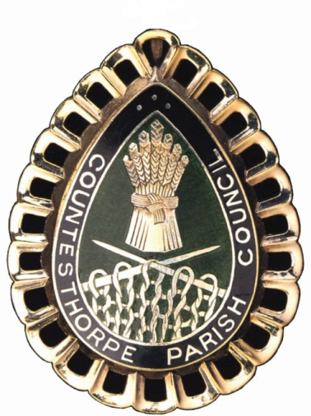

JOB DESCRIPTION
Parish Council Manager

Overall Responsibilities
The Parish Council Manager will be the Proper Officer of the Council and as such is under a statutory duty to carry out all the functions, and in particular to serve or issue all the notifications required by law of a local authority's Proper Officer. The Parish Council Manager will be totally responsible for ensuring that the instructions of the Council in connection with its function as a Local Authority are carried out. The Parish Council Manager is expected to advise the Council on, and assist in the formation of, overall policies to be followed in respect of the Authority's activities and in particular to produce all the information required for making effective decisions and to implement constructively all decisions. The person appointed will be accountable to the Council for the effective management of all its resources and will report to them as and when required. The Parish Council Manager will be the Responsible Financial Officer and responsible for all financial records of the Council and the careful administration of its finances. The Parish Council Manager is the Clerk to the Burial Board.

Specific Responsibilities
- To ensure that statutory and other provisions governing or affecting the running of the Council are observed.
- To monitor and balance the Council's accounts and prepare records for audit purposes and VAT.
- To ensure that the Council's obligations for Risk Assessment are properly met.
- To prepare, in consultation with appropriate members, agendas for meetings of the Council, its committees and working parties. To attend such meetings and prepare minutes for approval. Other than where such duties have been delegated to another Officer.
- To attend all meetings of the Council and all meetings of its committees and working parties. Other than where such duties have been delegated to another Officer.
- To receive correspondence and documents on behalf of the Council and to deal with the correspondence or documents or bring such items to the attention of the Council. To issue correspondence as a result of instructions of, or the known policy of the Council.
- To receive and report on invoices for goods and services to be paid for by the Council and to ensure such accounts are met. To issue invoices on behalf of the Council for goods and services and to ensure payment is received.
- To study reports and other data on activities of the Council and on matters bearing on those activities. Where appropriate, to discuss such matters with administrators and specialists in particular fields and to produce reports for circulation and discussion by the Council.
- To draw up both on his/her own initiative and as a result of suggestions by Councillors’ proposals for consideration by the Council and to advise on practicability and likely effects of specific courses of action.
- To manage any other members of staff as their line manager in keeping with the policies of the Council and to undertake all necessary activities in connection with the management of salaries, conditions of employment and work of other staff.
- To monitor the implemented policies of the Council to ensure they are achieving the desired result and where appropriate suggest modifications.
- To act as the representative of the Council as required.
- To issue notices and prepare agendas and minutes for the Parish Meeting: to attend the assemblies of the Parish Meeting and to implement the decisions made at the assemblies that are agreed by the Council.
- To attend training courses or seminars on the work and role of the Clerk as required by the Council.
- To administer the duties of the Burial Board including all statutory requirements.
- To carry out the day to day duties required by the Village Hall Management Committee for the Village Hall and the Library Committee for Countesthorpe Library
- To continue to acquire the necessary professional knowledge and training required for advising the Council.

